DC-USB
6-34V 10A, Intelligent DC-DC converter with USB interface
Quick Installation Guide
Version 1.0c
P/N DC-USB
Introduction
The DC-USB is a small yet powerful DC-DC power supply designed to
power a wide variety of devices. This DC-DC has a r ange of intelligent
functions not found in any tradition USB converters. Features include USB
interface, programmable output voltage and scripting as well as automotive
modes.
The DC-USB dev ice is able to send ON/OFF ‘pulse signals’ to
motherboards based on voltage levels or Ignition sensing, making it an ideal
device for automotive or battery powered installations.
This unit has a wide input range (6-34V) and it can prov ide a tightly regulated
output ranging from 6 to 24V (default set to 12V).
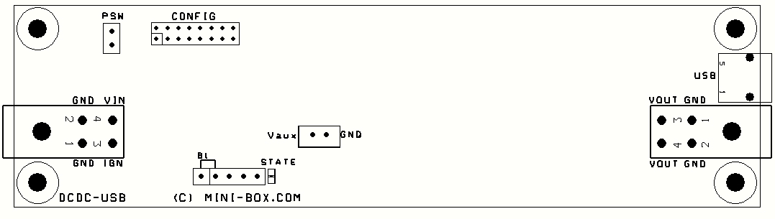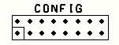
Mini-Box.com ATX DC-DC Converter Series
Quick installation Instru ctions
Fig 1.0, DC-USB layout
CONF IG:
Configuration jumpers for Voltage, Mode and Timings.
Left m ini-FIT connector
: Power input, V(in), GND, Ignition.
Right mini-FIT connector
: Power output V(out), GND.
PSW:
Soft ON/OFF control for motherboard. Connect this to motherboard
ON/OFF pins if you want the motherboard to be controlled by the unit.
USB:
mini-USB type B jack. Connect this to a PC to access advanced
settings.
STATE
: State LED
Vaux:
Provides unregulated switched input, to be used in automotive modes
to power various peripherals. Also, in automotiv e mode, Vaux can be used as
‘thump’. Vaux should be closer to V(In) in this case.
Basic Op eration
For basic operation, you would need to connect a power source to V(In).
V(IN) is on the left side of the board, near the 10A input fuse. Polarity is
marked on the PCB (GND, V(In) and Ignition). O n the cable harness, GND is
black, V(in) is red and Ignition is white. NOT E: Ignition is not needed for basic
operation.
Without any further settings, V(out) will generate 12V regulated. V(out) is
located on the right side of the PCB, near the USB connector. On the cable
harness, Yellow is positive and GND is negative.
Configuration jumpers
The configuration header (marked CONFIG) is the most important header in
this board. It is divided in 3 sections:
Tim ing Schem es
Main mod e
Ou tput voltage
DC-USB Quick Installation G uide Page 2
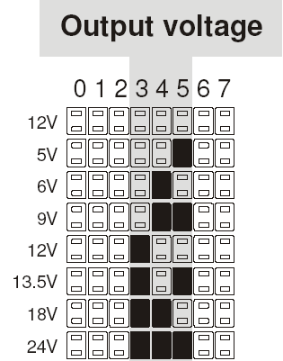
Mini-Box.com ATX DC-DC Converter Series
Main mode.
This header section sets one of the 3 main mode of operation:
DUMB mode, Automotive mode and the SCRIPT mode.
Output voltage.
This header section sets the output voltage of the unit.
Timing Schemes.
This header section sets the OFFDELAY and HARDOFF
timers, only av ailable in the Automotive mode.
Configuration, voltage settings
By default, the DC-USB module provides regulated 12V output. Should
you need other voltage levels, you can change output voltages by setting
jumpers 3, 4 and 5, see table 1.
After making a jumper change, the DC-USB unit needs to be power cycled
in order for the new setting to take effect.
NOTE:
These settings are factor y
defaults. They can all be changed with the DC-USB software. F or this, see
Advanced USB Configuration manual.
Configuration, Mod e of Op eration
DC-USB has 4 modes of oper ation. This modes c an be changed via
jumpers.
1) DUMB mode
. The units acts as a regular DC-DC converter. Only V(In) and
V(out) and GND terminal are required. Unit will conv ert any input from 6-34V
to a fixed voltage. Default voltage is set to 12V.
2) AUTOMOTIVE MODE.
In this mode, the unit acts as as Intelligent DC-DC
converter that is aware of Ignition state. In this mode the unit reads the
Ignition terminal and based on Ignition status the unit sends ON/OFF pulses
to a motherboard in order to start or stop. In this mode, two variables can be
set: OF FDELAY and HARDOFF . See Default Timing Schemes for more
information.
DC-USB Quick Installation G uide Page 3
Mini-Box.com ATX DC-DC Converter Series
3) SCRIPT MODE.
T his is an adv anced mode where unit can be scripted to
perform various tasks based on user scripts. Please refer to Advanced USB
programming manual for more details.
4) UPS MODE.
Module is a DC UPS (Uninterruptible Power Source) module.
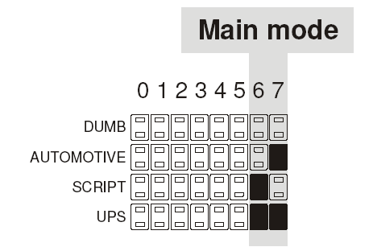

Default Timing Schem es
When unit is set to oper ate in the Automotiv e Mode, 8 timing settings are
available. These are combinations of OFFDELAY and HARDOF F timers.
NOTE: These settings are factory defaults. They can all be changed with the
DC-USB software. F or this, see Adv anced USB Configuration manual.
These settings work only when the Ignition wire is used.
OFFDELAY
is the amount of time the unit waits until it sends an ON/OFF
pulse the motherboard’s ON/OFF pins after Ignition has been turned off.
HARDOFF
is the amount of time the unit will still provide power after the
ON/OFF pulse has been sent to the motherboard. If you have a battery
sensitive application, set the HARDOFF to 1 minute to avoid battery drain.
While in HARDOF F, the unit carefully monitors the battery and if battery
voltage goes under 11.2V, power will be cut off in order to prevent battery
drainage.
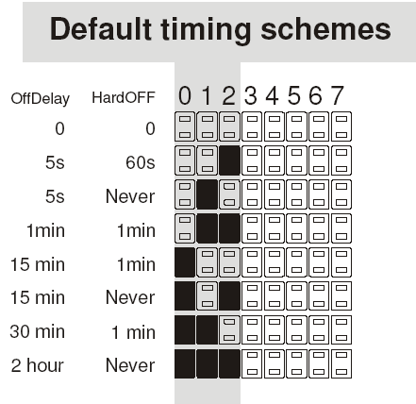

Mini-Box.com ATX DC-DC Converter Series
Electrical and Environmental Specifications
Minimum Input Operating voltage 6V
Maximum input Operating voltage Electronic shut down at 34V (clamping will occur
at 34-36V)
Deep-Discha rge shutdown threshold 11.2V
Input current limit (fuse protected) 10A (10A mini-blade fuse)
Max Output Powe r 100watts (lim ited by 10A input fuse) *
Regulation accuracy 2.5%
Operating temperature -40 to +85 degre es Celsius
Storage tempe rature -55 to +85 degrees Celsius
MTBF >100,000 hrs @ 65C body temp.
Effic iency (Input 9-16V) >95% (output = 12V 2A)
PCB size 135mx37mm
Input, output connectors Right angle, Mini-FIT JR 4 pin
*NOTE: At output power greater than 40watts or if unit temperature exceeds
65C, forced air ventilation will be required in order to prevent unit from
excessive thermal stress for long period of times.
12V outpu t m ax current charts
Input (V) 12V rail curre nt Input (V) 12V ra il curre nt
6V 4A 11V 8A
7V 5A 12V 8A
8V 6A 14V 8A (10A peak)
9V 7A 14-18V 8A (10A peak)
10V 8A 20-26V 8A
Operating environment
: Temperature: -20 to 65 degree centigrade.
Relative Humidity: 10 to 90 percent, non-condensing.
Efficien cy, MTBF:
MTBF >100K hours at PSU (temp) < 65 Celsius.
NOTE: All solid polymer capacitor design, rated >50K hours at 85C or 500K
hours at 65C.
Shipp ing and sto rage:
Temperature -40 to +85 degree centigr ade.
Relative humidity 5 to 95 percent, non-condensing.
Warranty
1 Year Limited W arranty statement. Warranty is void if maintenance or
calibration is performed by end-user or by use in conjunction with power
modules not prov ided by mini-box.com.

