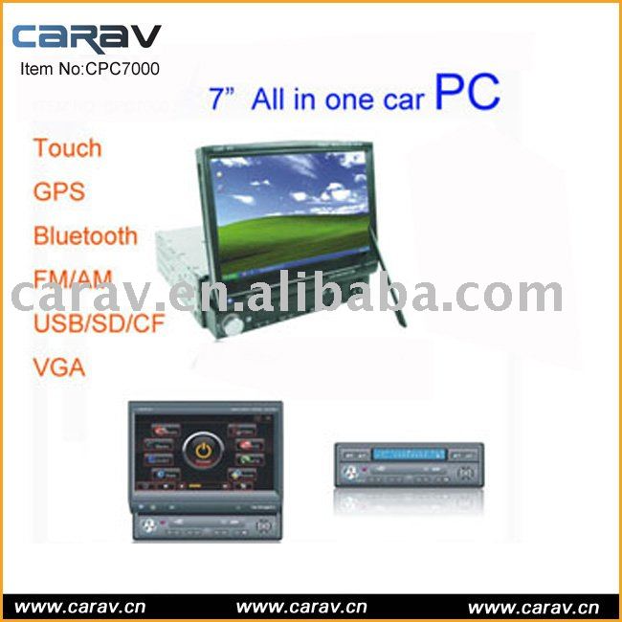

Type:
car pc
Functions::
7" touch screen with CAR PC, motorized function with CF,SD,USB port.
Special ::
GPS function included,with Bluetooth,WIFI optional
Function:
MOTORIZED CAR PC TOUCH SCREEN
Screen Size:
7 inch
Placement:
IN DASH
Place of Origin:
Guangdong, China
Model Number:
CPC7000

7" Touchscreen 1-DIN Indash Full motorized CAR PC
System parameters
CPU: VIA C7 1.2G
System FSB: 533 MHz
Memory: DDR the second laptop mermory 256M/512M/1G
HDD: Expert Electronic anti-shake HDD 2G/4G/8G
Monitor: Fully motorized 7inch digital display can turn
right/left , up /down
Operation System: Windows2000/XP , Linux ,WinCE
Bluetooth: Built bluetooth ( optional )
GPS Navigation: GPS software built-in ( optional )
USB Transmit: 2pcs USB2.0 High Speed Port;
Wireless network: Use GPRS/CDMA /3G for surfing
Hardware acceleration: 2D/3D display accelerate chip support MPEG-2 hardware decode.MPEG-4 and HDTV for digital-video playing
Mobile Office: OFFICE and E-mail/QQ/skype and Picture Designed
Medio display: Support all MPEG1,2,3,4 , AVI,DIVX
,XVID,WMV, RMVB, RM ,H263,MOV ,3GP , WAV
Photo fomat: JPEG , BMP,GIF and so on
Audio Output: Built Mic and Earphone,4 Audio Output
Video Input: 1 Video rearview single input
VGA output: 1 VGA Signal output for dual displays
Series port: 1pcs Series port output
AM/FM: Touch for the OSD Menu and Amplifer Menu.40pcs
stored in Radio Mode
ITPS: ITPS AUTO SWITCH OFF
Card reader: SD , CF card set
Amplifier: 4×45W
Power Supply: DC 6V-26V
Indash Monitor: Fully motorized

